#Initial document created by sujatha on sep-28-2021

Get your latested version from the github:

<https://github.com/Sujatha-Renga/ISQA3900_Group10_Project.git>

Create your virtual environment and project structure sample is below

Open Setting.py file

1.Check your app is installed in the

INSTALLED_APPS = [

‘django.contrib.admin’,

‘django.contrib.auth’,

‘django.contrib.contenttypes’,

‘django.contrib.sessions’,

‘django.contrib.messages’,

‘django.contrib.staticfiles’,

‘orders’,

]

2. Add **import os** near line 12 in the file **t**hen

3 Add **TIME_ZONE = 'America/Chicago'** in the same file

**python manage.py runserver**

**Document updated by Karpagam on 9/30/2021 @ 1.53PM**

**Update settings.py file with import.os**

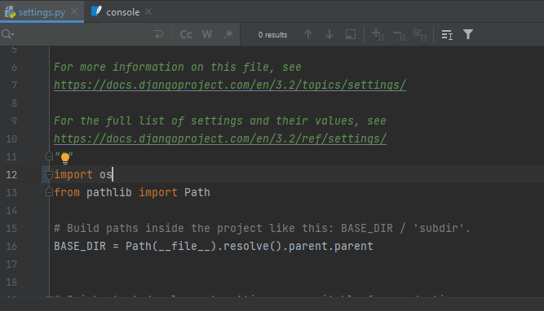

Create super user:

Username: adminuser

Password: superman

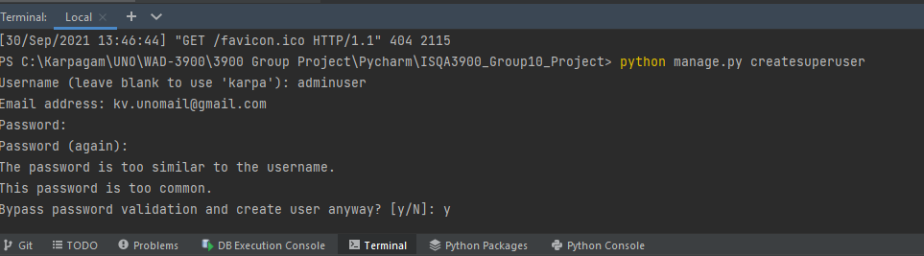

python manage.py runserver

and check for the below link to see

<http://127.0.0.1:8000/admin>

